Week 6 day 1 and 2- 10th November
SEQUENTIAL BUILDER AGENT-ASSIGNMENT
USE ANY FREE MODEL WHICH IS AGENTIC
https://drive.google.com/drive/folders/1b02JuN_8OIKNFbya6GRa8CzcIs8nHWBa?usp=sharing
pip install -r requirements.txt
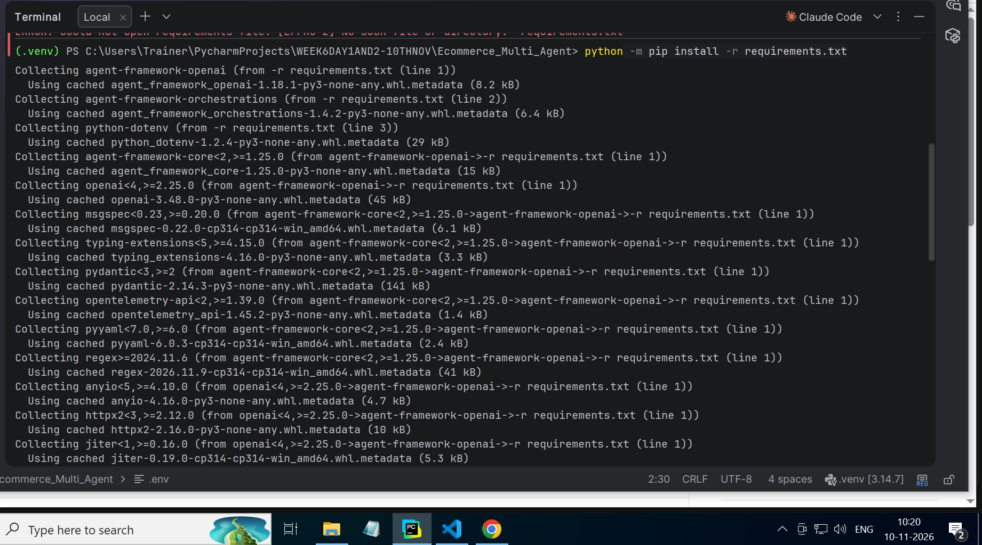
OUTPUT for test_tools.py:
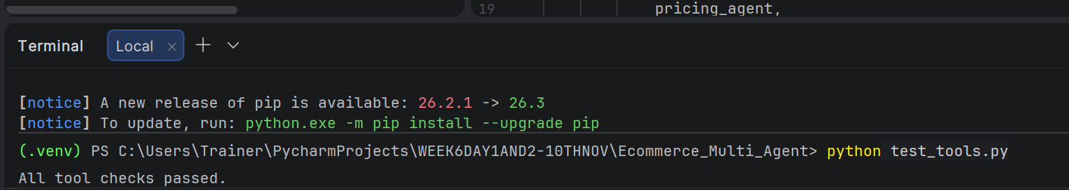

FINAL OUTPUTS:
- Recommend 2 laptops within ₹1,20,000 total.
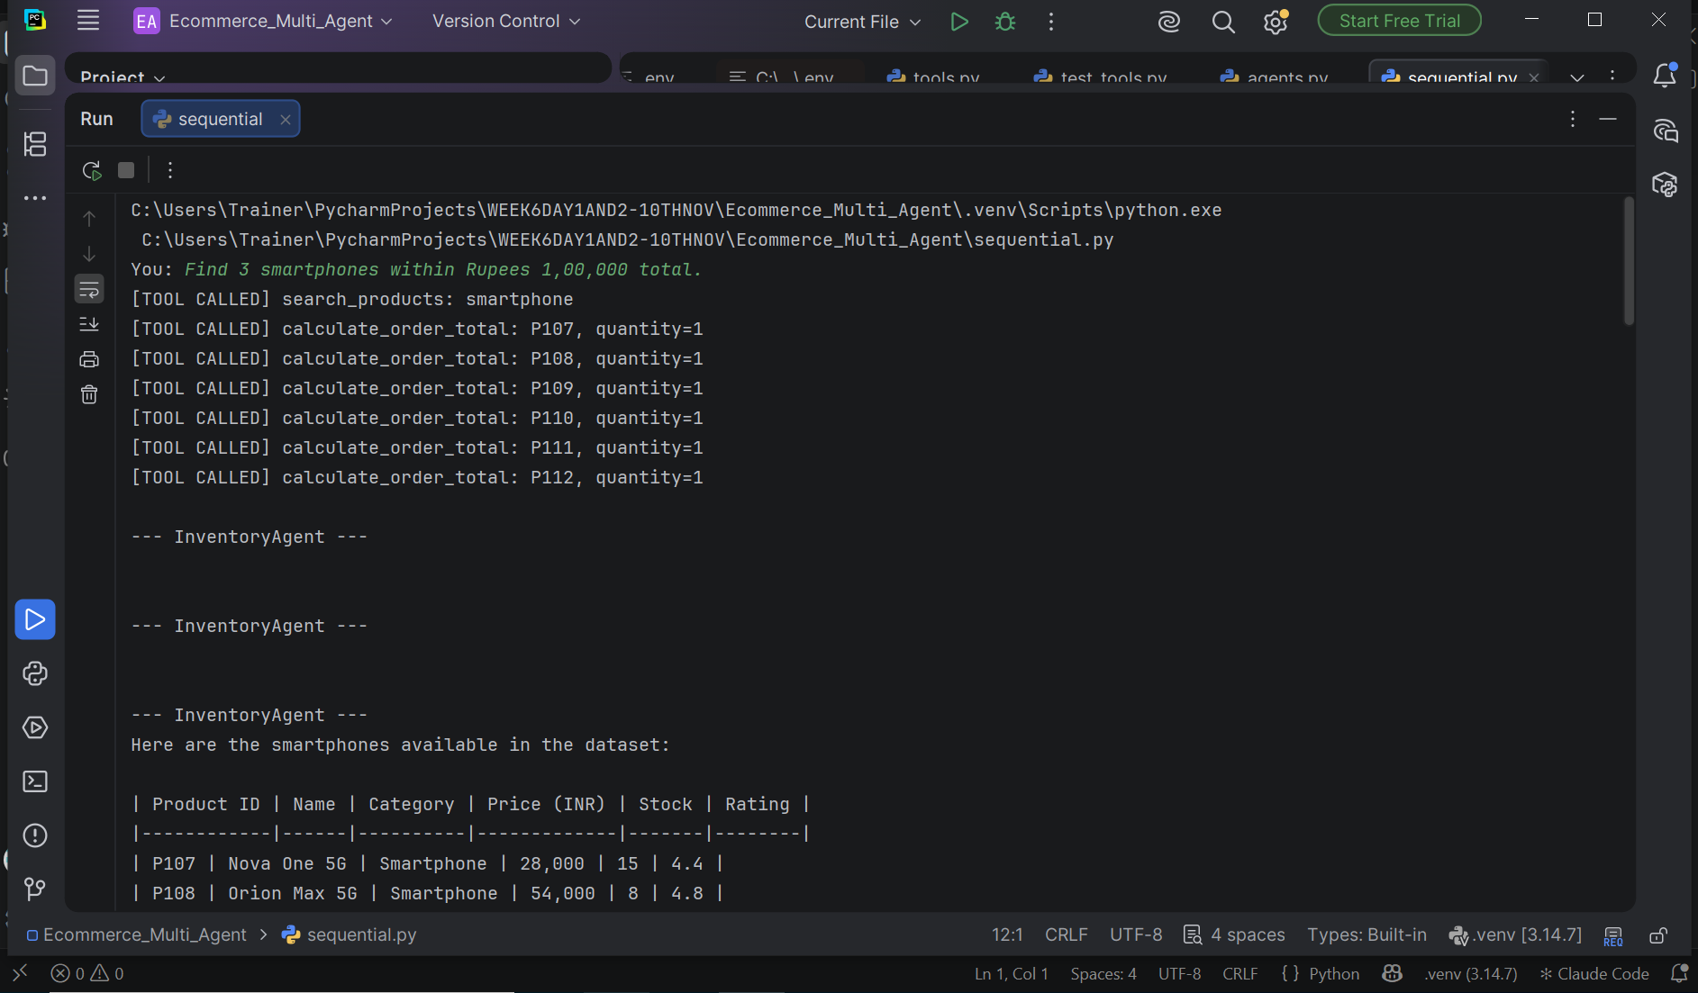
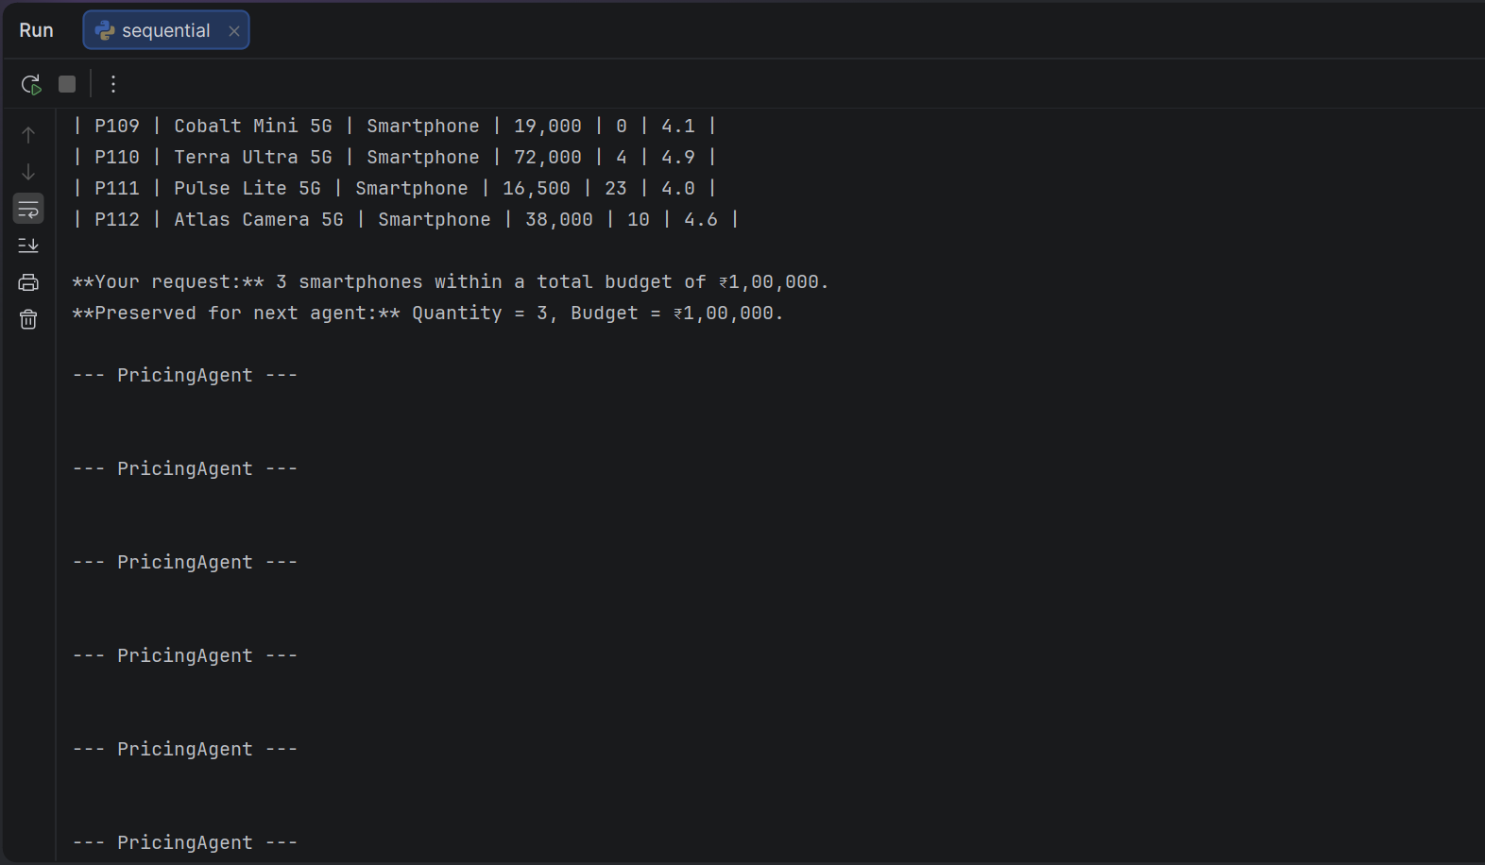
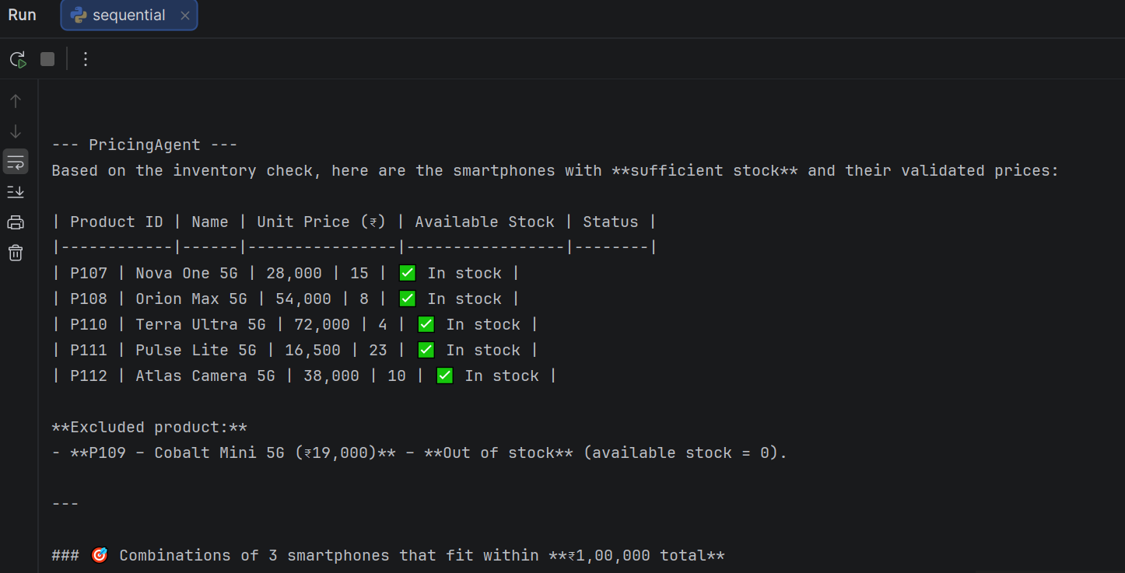
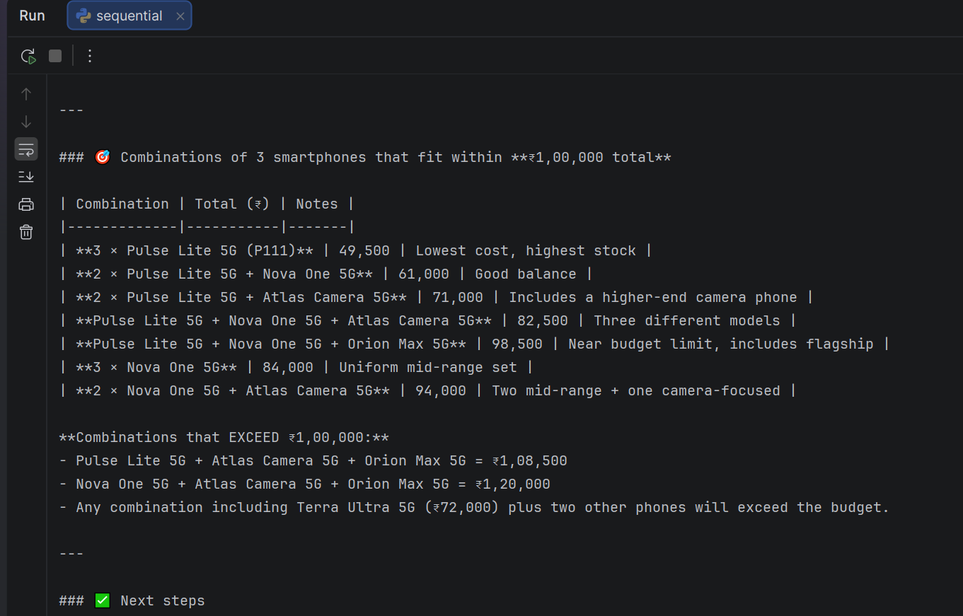
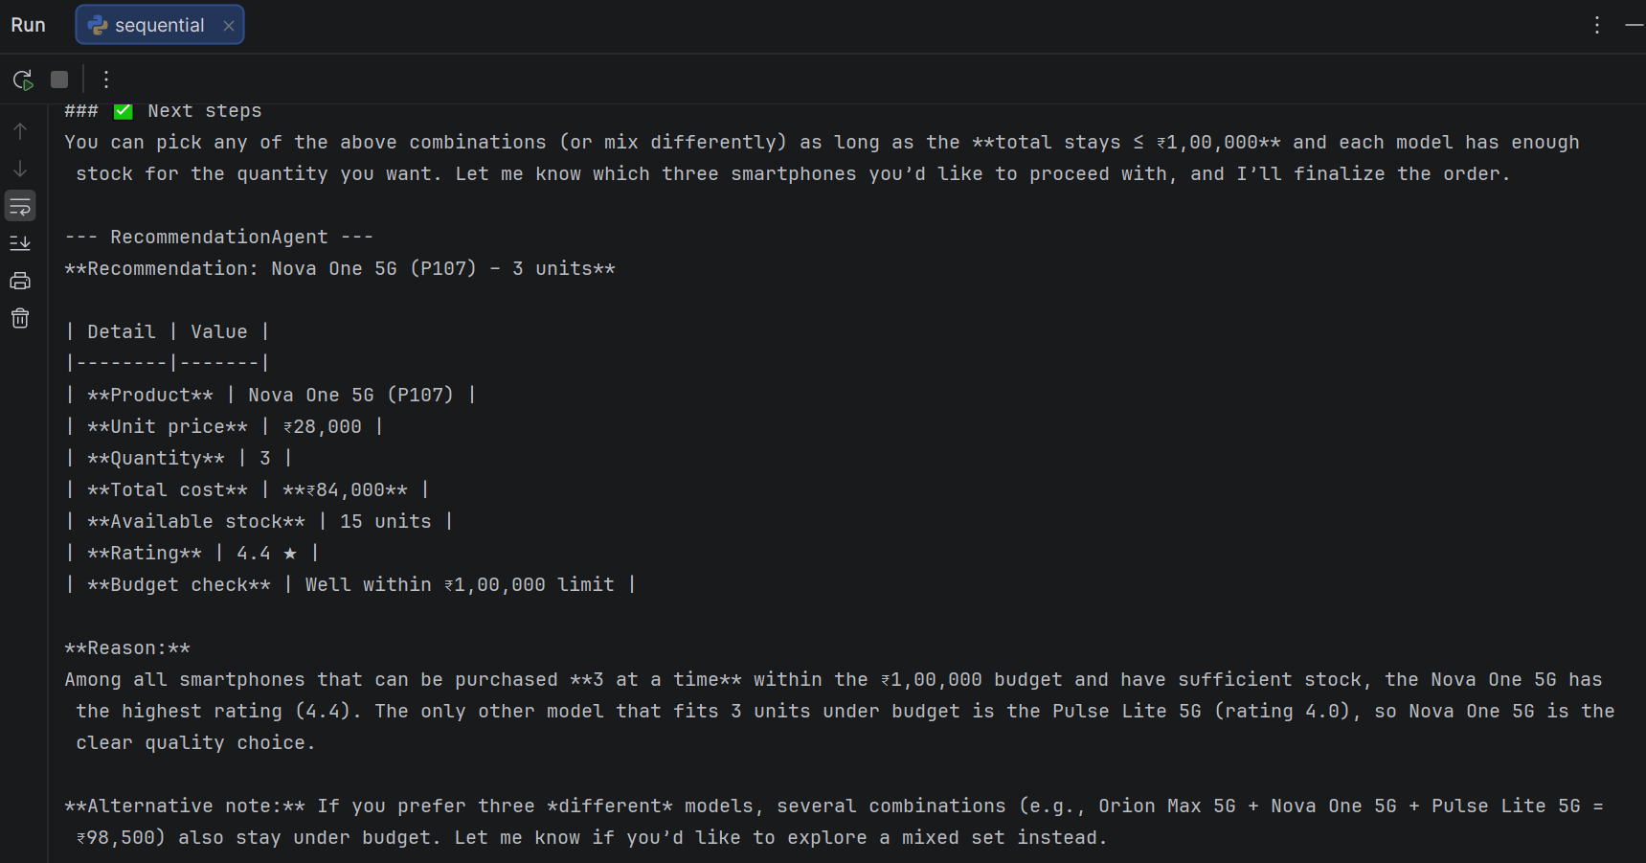
Using groq:
You: Recommend 2 laptops within Rs. 1,20,000 total.
[TOOL CALLED] search_products: laptop
[TOOL CALLED] compare_product_options: category=Laptop, quantity=2, budget_inr=120000

--- InventoryAgent ---

--- InventoryAgent ---

--- InventoryAgent ---
**Products found (Laptop category)**

| Product ID | Price (INR) | Stock | Rating |
|------------|-------------|-------|--------|
| P101 | 52,000 | 8 | 4.5 |
| P102 | 68,000 | 3 | 4.8 |
| P103 | 41,000 | 0 | 4.1 |
| P104 | 59,000 | 12 | 4.7 |
| P105 | 92,000 | 5 | 4.9 |
| P106 | 34,500 | 20 | 4.2 |

**Request details for the next agent**
- Quantity: **2 laptops**
- Budget: **Rs. 1,20,000** (total)

--- PricingAgent ---

--- PricingAgent ---

--- PricingAgent ---
**Recommendation based on the authoritative comparison**

| Option | Products (ID – Name) | Quantity | Unit Price (INR) | Line Total (INR) | Total (INR) | Average Rating |
|--------|---------------------|----------|------------------|------------------|-------------|----------------|
| **Best single‑model** | P104 – *Atlas Work 14* | 2 | 59 000 | 118 000 | **118 000** | 4.70 |
| **Best mixed‑model** | P101 – *NovaBook Air 14* (1) & P102 – *Orion Pro 15* (1) | 1 + 1 | 52 000 & 68 000 | 52 000 & 68 000 | **120 000** | 4.65 |

*Both options satisfy the requested quantity of 2 laptops and stay within the total budget of ₹1,20,000. The single‑model option is slightly cheaper (₹118,000) and has a higher average rating (4.70). The mixed‑model option uses two distinct models but exactly matches the budget and offers a marginally lower overall rating (4.65). No unavailable options were reported.*

--- RecommendationAgent ---
**Single‑Model Option**

- **Products**
- ID: P104 – *Atlas Work 14*
- **Quantity**: 2
- **Unit price**: ₹ 59 000
- **Line total**: ₹ 118 000
- **Total cost**: ₹ 118 000
- **Average rating**: 4.70

This option satisfies the requested 2 laptops, stays within the ₹1,20,000 budget, and the stock of 12 units is sufficient for the 2‑unit order.

---

**Mixed‑Model Option**

- **Products**
- ID: P101 – *NovaBook Air 14* (quantity 1)
- ID: P102 – *Orion Pro 15* (quantity 1)
- **Unit prices**:
- P101: ₹ 52 000 → line total ₹ 52 000
- P102: ₹ 68 000 → line total ₹ 68 000
- **Total cost**: ₹ 120 000
- **Average rating**: 4.65

This mixed‑model configuration also fulfills the 2‑laptop request, meets the ₹1,20,000 total budget, and each product’s stock (8 for P101 and 3 for P102) covers the requested quantities.

Process finished with exit code 0
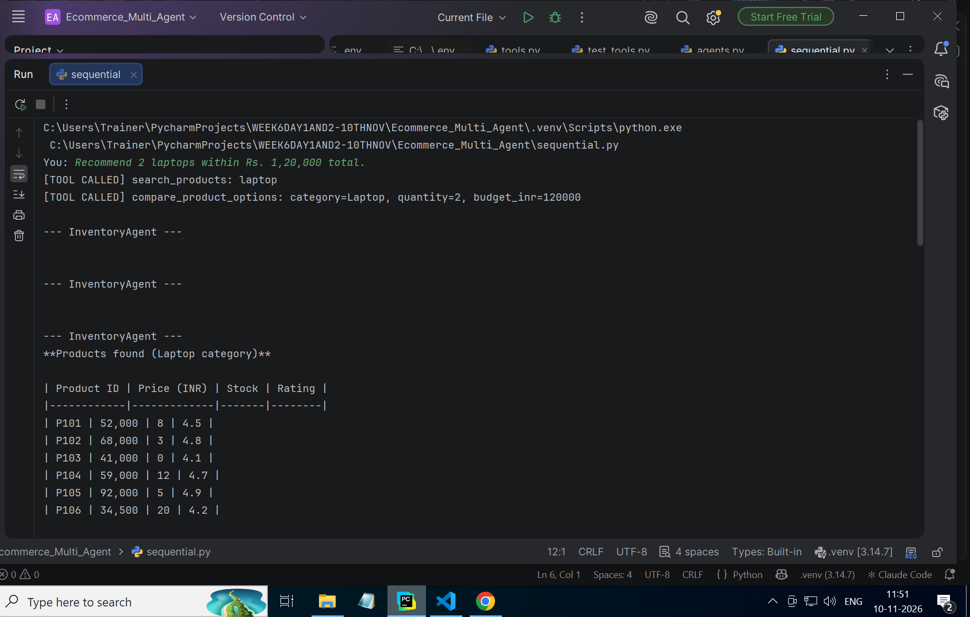
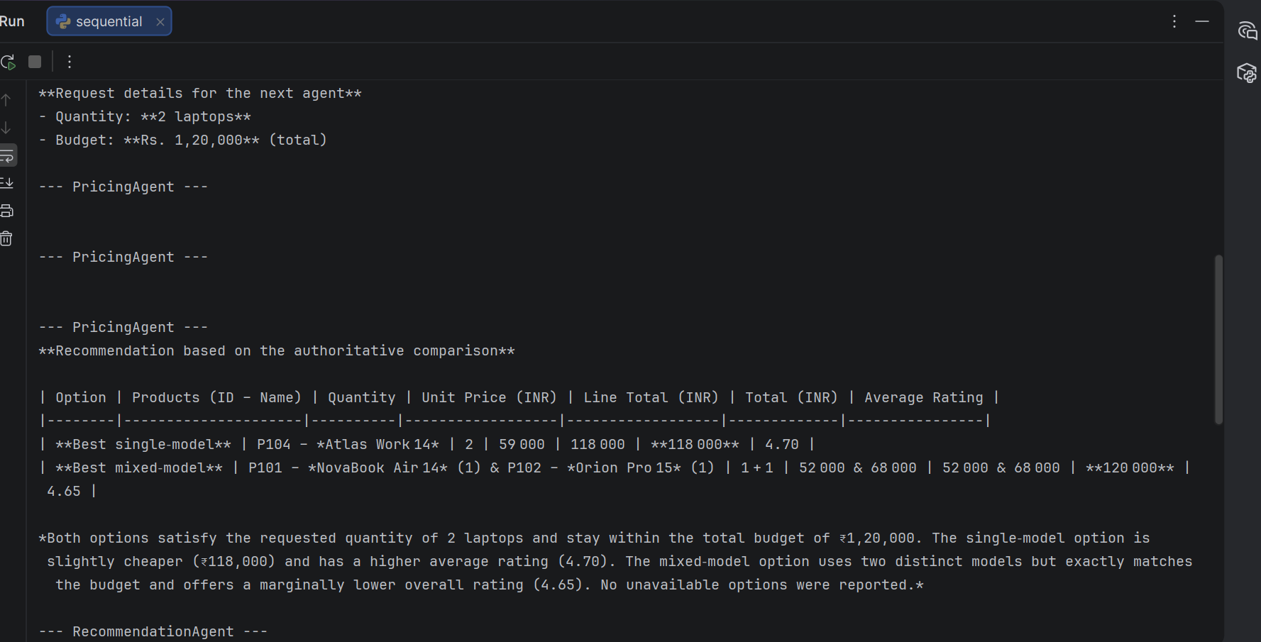
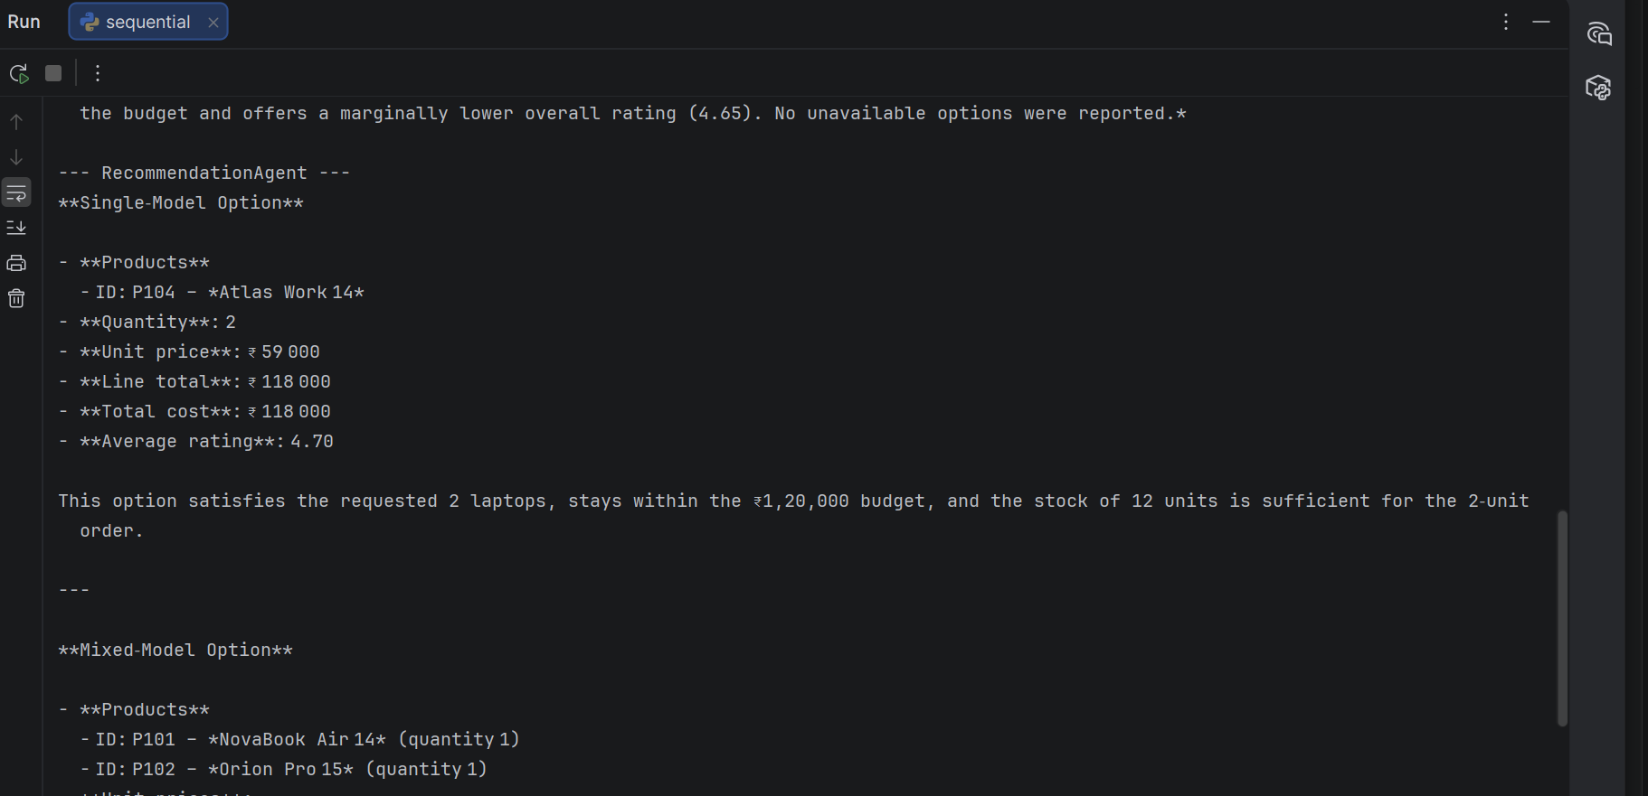
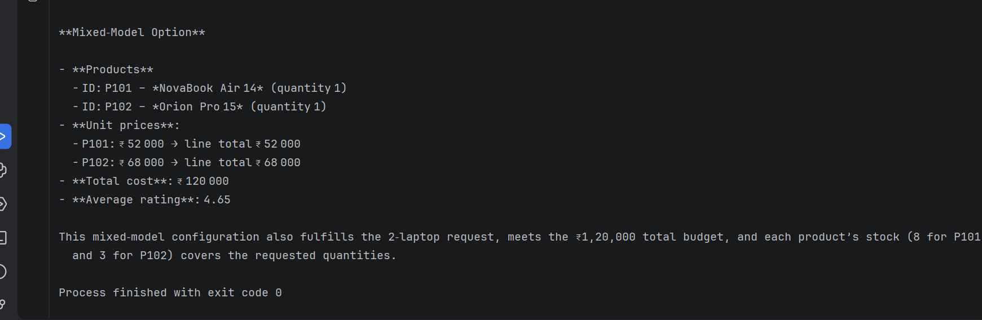

- Find 3 smartphones within rs. 1,00,000 total.
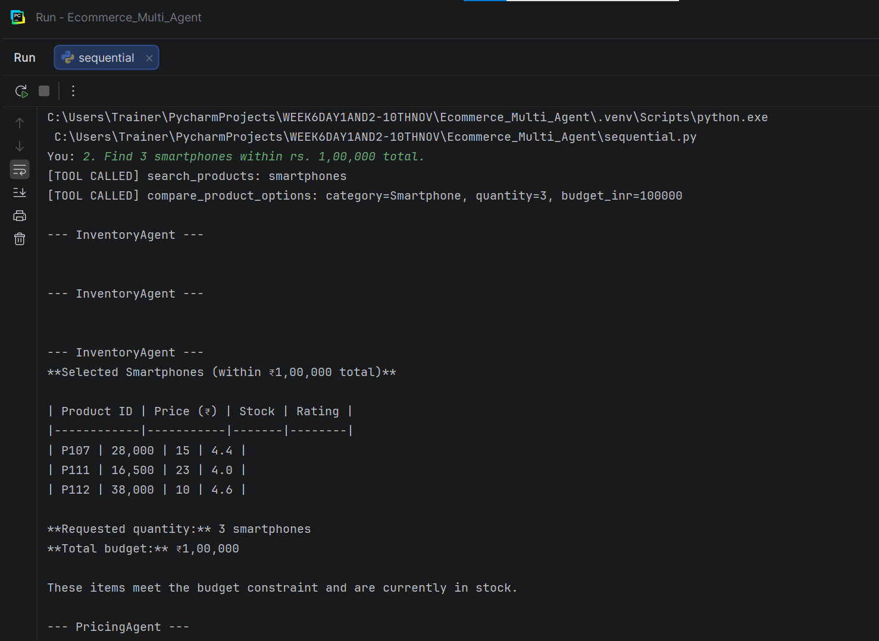
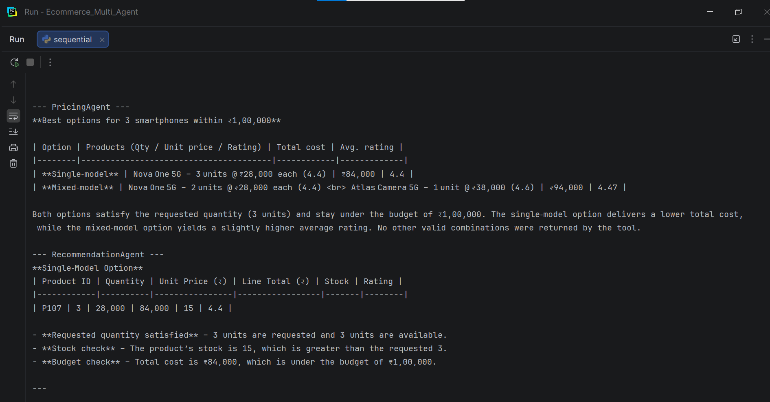
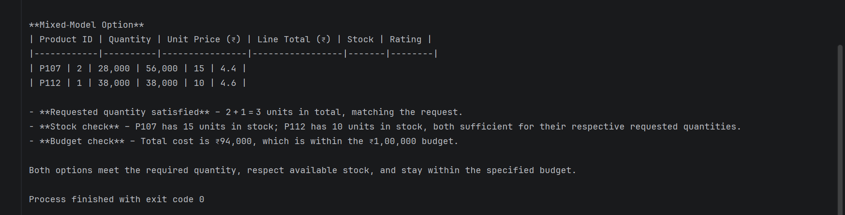
You: 2. Find 3 smartphones within rs. 1,00,000 total.
[TOOL CALLED] search_products: smartphones
[TOOL CALLED] compare_product_options: category=Smartphone, quantity=3, budget_inr=100000

--- InventoryAgent ---

--- InventoryAgent ---

--- InventoryAgent ---
**Selected Smartphones (within ₹1,00,000 total)**

| Product ID | Price (₹) | Stock | Rating |
|------------|-----------|-------|--------|
| P107 | 28,000 | 15 | 4.4 |
| P111 | 16,500 | 23 | 4.0 |
| P112 | 38,000 | 10 | 4.6 |

**Requested quantity:** 3 smartphones
**Total budget:** ₹1,00,000

These items meet the budget constraint and are currently in stock.

--- PricingAgent ---

--- PricingAgent ---

--- PricingAgent ---
**Best options for 3 smartphones within ₹1,00,000**

| Option | Products (Qty / Unit price / Rating) | Total cost | Avg. rating |
|--------|---------------------------------------|------------|-------------|
| **Single‑model** | Nova One 5G – 3 units @ ₹28,000 each (4.4) | ₹84,000 | 4.4 |
| **Mixed‑model** | Nova One 5G – 2 units @ ₹28,000 each (4.4) <br> Atlas Camera 5G – 1 unit @ ₹38,000 (4.6) | ₹94,000 | 4.47 |

Both options satisfy the requested quantity (3 units) and stay under the budget of ₹1,00,000. The single‑model option delivers a lower total cost, while the mixed‑model option yields a slightly higher average rating. No other valid combinations were returned by the tool.

--- RecommendationAgent ---
**Single‑Model Option**
| Product ID | Quantity | Unit Price (₹) | Line Total (₹) | Stock | Rating |
|------------|----------|----------------|-----------------|-------|--------|
| P107 | 3 | 28,000 | 84,000 | 15 | 4.4 |

- **Requested quantity satisfied** – 3 units are requested and 3 units are available.
- **Stock check** – The product’s stock is 15, which is greater than the requested 3.
- **Budget check** – Total cost is ₹84,000, which is under the budget of ₹1,00,000.

---

**Mixed‑Model Option**
| Product ID | Quantity | Unit Price (₹) | Line Total (₹) | Stock | Rating |
|------------|----------|----------------|-----------------|-------|--------|
| P107 | 2 | 28,000 | 56,000 | 15 | 4.4 |
| P112 | 1 | 38,000 | 38,000 | 10 | 4.6 |

- **Requested quantity satisfied** – 2 + 1 = 3 units in total, matching the request.
- **Stock check** – P107 has 15 units in stock; P112 has 10 units in stock, both sufficient for their respective requested quantities.
- **Budget check** – Total cost is ₹94,000, which is within the ₹1,00,000 budget.

Both options meet the required quantity, respect available stock, and stay within the specified budget.

Process finished with exit code 0
- Recommend 2 monitors within ₹50,000 total.
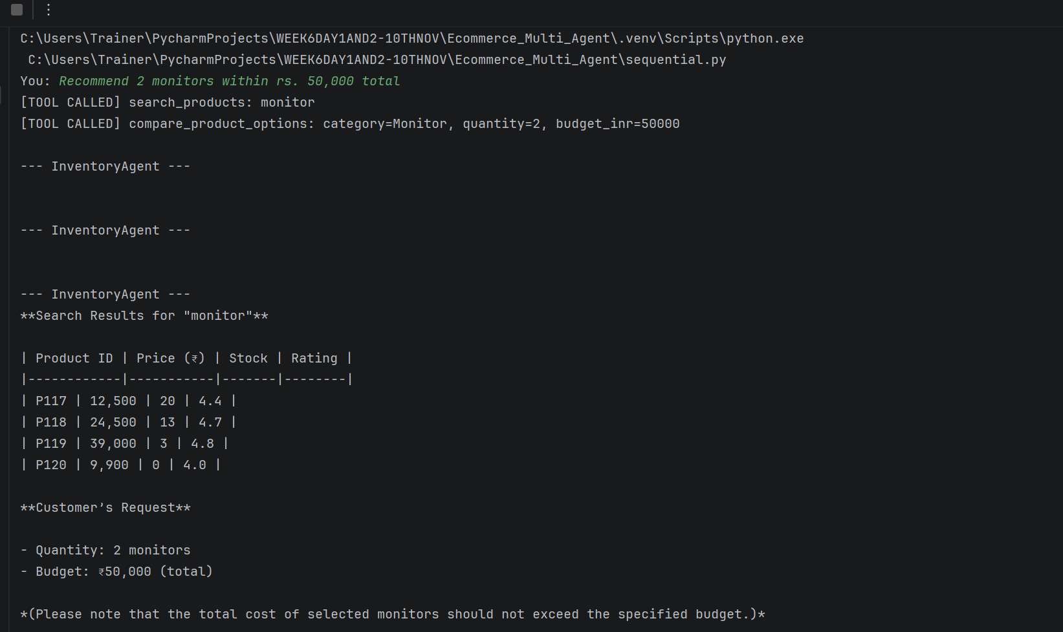
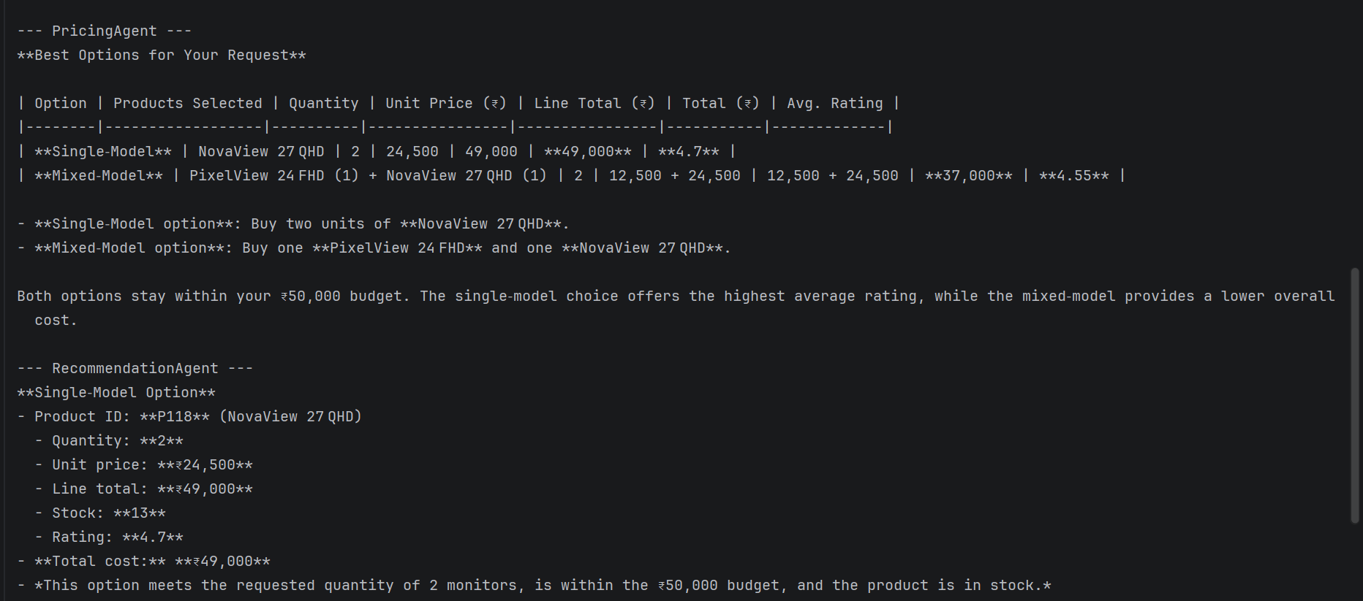
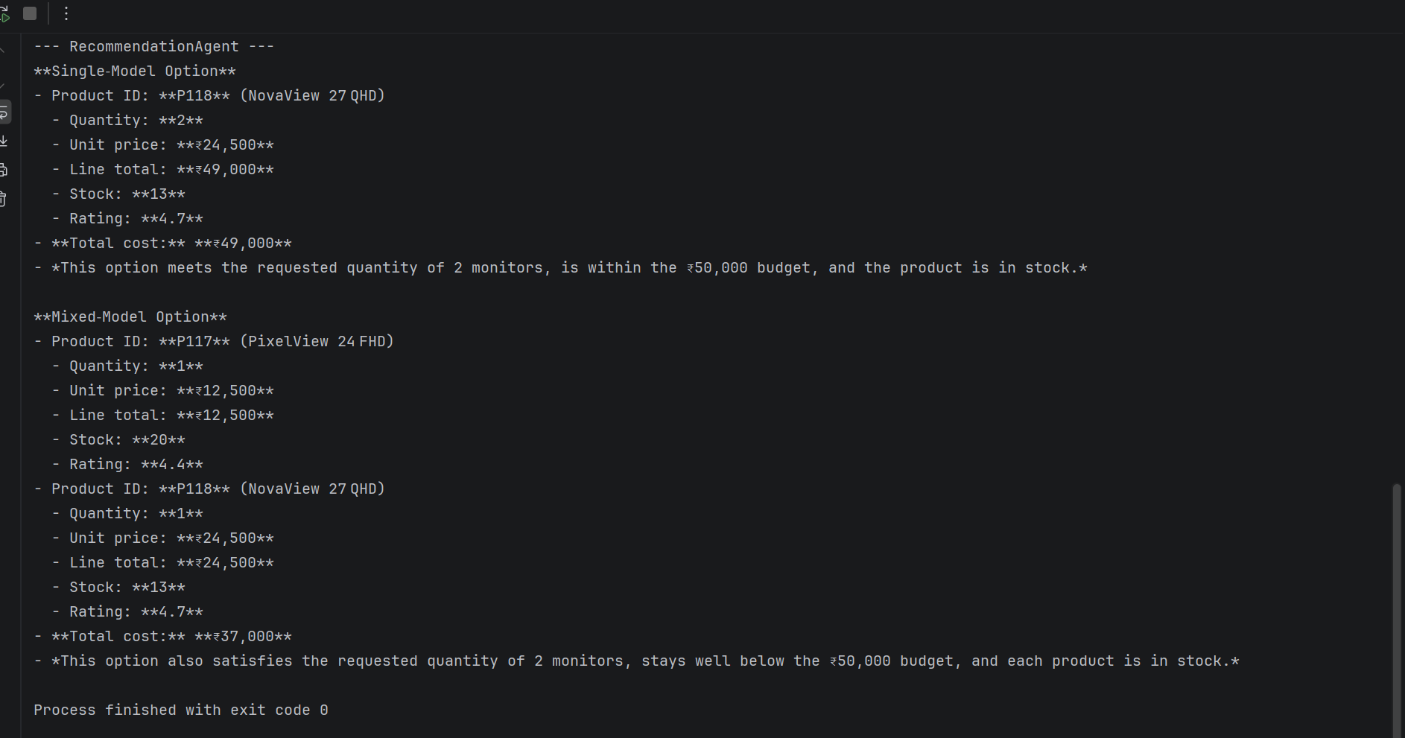
C:\Users\Trainer\PycharmProjects\WEEK6DAY1AND2-10THNOV\Ecommerce_Multi_Agent\.venv\Scripts\python.exe C:\Users\Trainer\PycharmProjects\WEEK6DAY1AND2-10THNOV\Ecommerce_Multi_Agent\sequential.py
You: Recommend 2 monitors within rs. 50,000 total
[TOOL CALLED] search_products: monitor
[TOOL CALLED] compare_product_options: category=Monitor, quantity=2, budget_inr=50000

--- InventoryAgent ---

--- InventoryAgent ---

--- InventoryAgent ---
**Search Results for "monitor"**

| Product ID | Price (₹) | Stock | Rating |
|------------|-----------|-------|--------|
| P117 | 12,500 | 20 | 4.4 |
| P118 | 24,500 | 13 | 4.7 |
| P119 | 39,000 | 3 | 4.8 |
| P120 | 9,900 | 0 | 4.0 |

**Customer’s Request**

- Quantity: 2 monitors
- Budget: ₹50,000 (total)

*(Please note that the total cost of selected monitors should not exceed the specified budget.)*

--- PricingAgent ---

--- PricingAgent ---

--- PricingAgent ---
**Best Options for Your Request**

| Option | Products Selected | Quantity | Unit Price (₹) | Line Total (₹) | Total (₹) | Avg. Rating |
|--------|------------------|----------|----------------|----------------|-----------|-------------|
| **Single‑Model** | NovaView 27 QHD | 2 | 24,500 | 49,000 | **49,000** | **4.7** |
| **Mixed‑Model** | PixelView 24 FHD (1) + NovaView 27 QHD (1) | 2 | 12,500 + 24,500 | 12,500 + 24,500 | **37,000** | **4.55** |

- **Single‑Model option**: Buy two units of **NovaView 27 QHD**.
- **Mixed‑Model option**: Buy one **PixelView 24 FHD** and one **NovaView 27 QHD**.

Both options stay within your ₹50,000 budget. The single‑model choice offers the highest average rating, while the mixed‑model provides a lower overall cost.

--- RecommendationAgent ---
**Single‑Model Option**
- Product ID: **P118** (NovaView 27 QHD)
- Quantity: **2**
- Unit price: **₹24,500**
- Line total: **₹49,000**
- Stock: **13**
- Rating: **4.7**
- **Total cost:** **₹49,000**
- *This option meets the requested quantity of 2 monitors, is within the ₹50,000 budget, and the product is in stock.*

**Mixed‑Model Option**
- Product ID: **P117** (PixelView 24 FHD)
- Quantity: **1**
- Unit price: **₹12,500**
- Line total: **₹12,500**
- Stock: **20**
- Rating: **4.4**
- Product ID: **P118** (NovaView 27 QHD)
- Quantity: **1**
- Unit price: **₹24,500**
- Line total: **₹24,500**
- Stock: **13**
- Rating: **4.7**
- **Total cost:** **₹37,000**
- *This option also satisfies the requested quantity of 2 monitors, stays well below the ₹50,000 budget, and each product is in stock.*

Process finished with exit code 0
- Find 5 headphones under rs. 20,000 total.
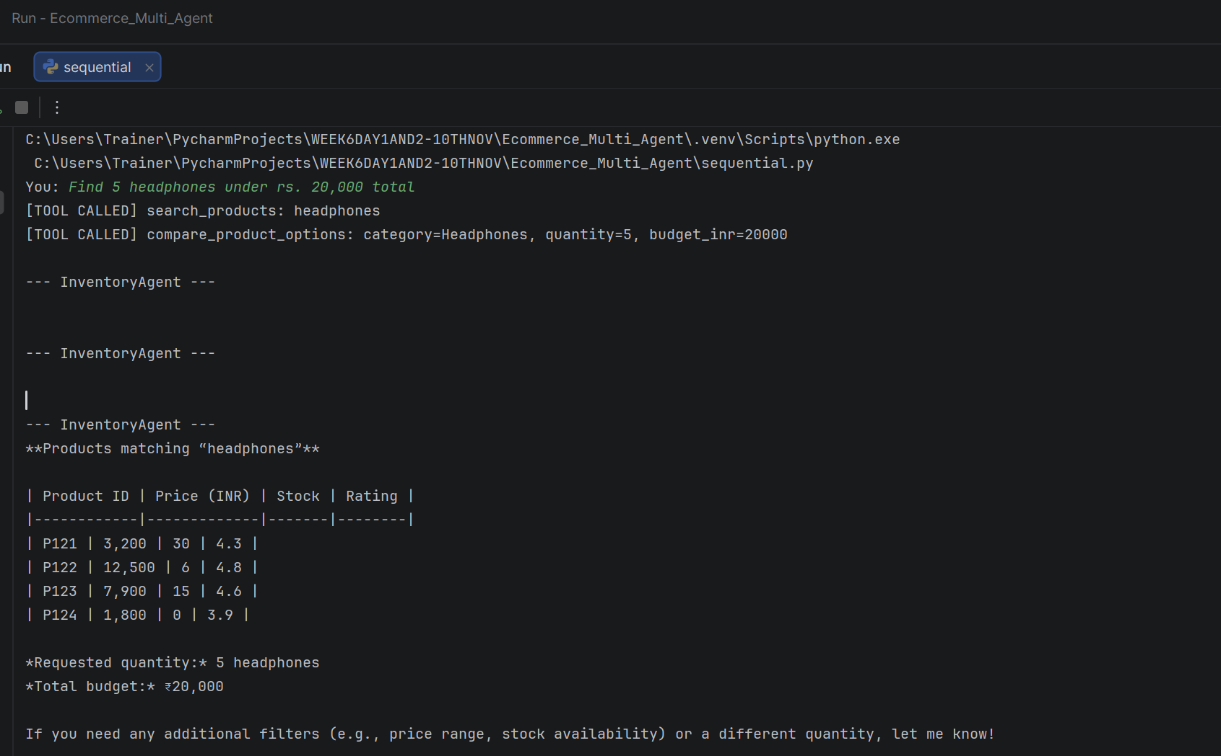
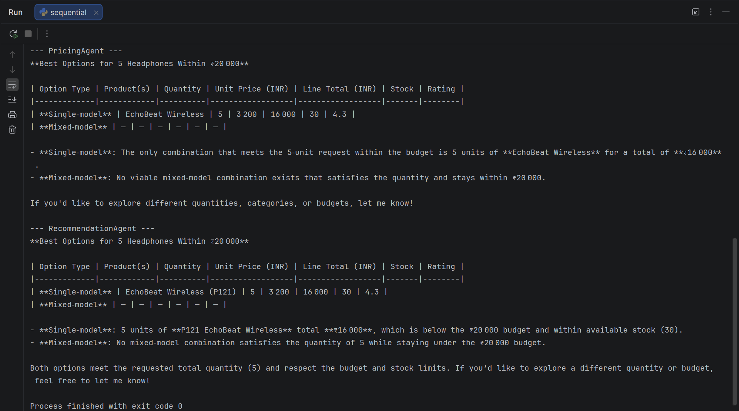
C:\Users\Trainer\PycharmProjects\WEEK6DAY1AND2-10THNOV\Ecommerce_Multi_Agent\.venv\Scripts\python.exe C:\Users\Trainer\PycharmProjects\WEEK6DAY1AND2-10THNOV\Ecommerce_Multi_Agent\sequential.py
You: Find 5 headphones under rs. 20,000 total
[TOOL CALLED] search_products: headphones
[TOOL CALLED] compare_product_options: category=Headphones, quantity=5, budget_inr=20000

--- InventoryAgent ---

--- InventoryAgent ---

--- InventoryAgent ---
**Products matching “headphones”**

| Product ID | Price (INR) | Stock | Rating |
|------------|-------------|-------|--------|
| P121 | 3,200 | 30 | 4.3 |
| P122 | 12,500 | 6 | 4.8 |
| P123 | 7,900 | 15 | 4.6 |
| P124 | 1,800 | 0 | 3.9 |

*Requested quantity:* 5 headphones
*Total budget:* ₹20,000

If you need any additional filters (e.g., price range, stock availability) or a different quantity, let me know!

--- PricingAgent ---

--- PricingAgent ---

--- PricingAgent ---
**Best Options for 5 Headphones Within ₹20 000**

| Option Type | Product(s) | Quantity | Unit Price (INR) | Line Total (INR) | Stock | Rating |
|-------------|------------|----------|------------------|------------------|-------|--------|
| **Single‑model** | EchoBeat Wireless | 5 | 3 200 | 16 000 | 30 | 4.3 |
| **Mixed‑model** | — | — | — | — | — | — |

- **Single‑model**: The only combination that meets the 5‑unit request within the budget is 5 units of **EchoBeat Wireless** for a total of **₹16 000**.
- **Mixed‑model**: No viable mixed‑model combination exists that satisfies the quantity and stays within ₹20 000.

If you'd like to explore different quantities, categories, or budgets, let me know!

--- RecommendationAgent ---
**Best Options for 5 Headphones Within ₹20 000**

| Option Type | Product(s) | Quantity | Unit Price (INR) | Line Total (INR) | Stock | Rating |
|-------------|------------|----------|------------------|------------------|-------|--------|
| **Single‑model** | EchoBeat Wireless (P121) | 5 | 3 200 | 16 000 | 30 | 4.3 |
| **Mixed‑model** | — | — | — | — | — | — |

- **Single‑model**: 5 units of **P121 EchoBeat Wireless** total **₹16 000**, which is below the ₹20 000 budget and within available stock (30).
- **Mixed‑model**: No mixed‑model combination satisfies the quantity of 5 while staying under the ₹20 000 budget.

Both options meet the requested total quantity (5) and respect the budget and stock limits. If you’d like to explore a different quantity or budget, feel free to let me know!

Process finished with exit code 0
- Recommend 2 tablets under Rs. 60,000 total.
C:\Users\Trainer\PycharmProjects\WEEK6DAY1AND2-10THNOV\Ecommerce_Multi_Agent\.venv\Scripts\python.exe C:\Users\Trainer\PycharmProjects\WEEK6DAY1AND2-10THNOV\Ecommerce_Multi_Agent\sequential.py
You: Recommend 2 tablets under Rs. 60,000 total
[TOOL CALLED] search_products: tablet
[TOOL CALLED] compare_product_options: category=Tablet, quantity=2, budget_inr=60000

--- InventoryAgent ---

--- InventoryAgent ---

--- InventoryAgent ---
**Recommended Tablets (2 units, total budget ≤ ₹60,000)**

| Product ID | Name | Price (₹) | Stock | Rating |
|------------|------|-----------|-------|--------|
| **P113** | NovaTab 10 | 21,000 | 10 | 4.2 |
| **P116** | AtlasTab Work | 32,500 | 11 | 4.5 |

*Both items are in stock and together total ₹53,500, which is within your ₹60,000 budget.*

**Next agent details**
- Quantity requested: **2**
- Budget: **₹60,000**

--- PricingAgent ---

--- PricingAgent ---

--- PricingAgent ---
**Category Requested:** Tablet
**Total Quantity Requested:** 2 units
**Total Budget:** ₹60 000

After checking inventory and pricing, here are the two best options that satisfy the constraints:

| Option | Products (Qty) | Unit Price (₹) | Line Total (₹) | Stock | Rating |
|--------|----------------|----------------|----------------|-------|--------|
| **Single‑model** | NovaTab 10 × 2 | 21 000 | 42 000 | 10 | 4.2 |
| **Mixed‑model** | NovaTab 10 × 1 + AtlasTab Work × 1 | 21 000 + 32 500 | 53 500 | 10 & 11 | 4.35 |

*Both options are in stock and stay within the ₹60 000 budget.*

The best single‑model option is **NovaTab 10 (2 units)**, and the best mixed‑model option is **NovaTab 10 (1 unit) + AtlasTab Work (1 unit)**. If you would like to proceed with either choice, let me know and I’ll finalize the order.

--- RecommendationAgent ---
**Single‑model option**

| Product ID | Quantity | Unit price (₹) | Line total (₹) | Stock | Rating |
|------------|----------|----------------|----------------|-------|--------|
| P113 | 2 | 21 000 | 42 000 | 10 | 4.2 |

*This option provides the requested 2 units, remains within the ₹60 000 budget, and the product is in stock.*

---

**Mixed‑model option**

| Product ID | Quantity | Unit price (₹) | Line total (₹) | Stock | Rating |
|------------|----------|----------------|----------------|-------|--------|
| P113 | 1 | 21 000 | 21 000 | 10 | 4.2 |
| P116 | 1 | 32 500 | 32 500 | 11 | 4.5 |

*This option also gives the requested 2 units, stays below the ₹60 000 budget, and both products have available stock.*

Process finished with exit code 0
- Find 10 printers within Rs 1,00,000 total.
C:\Users\Trainer\PycharmProjects\WEEK6DAY1AND2-10THNOV\Ecommerce_Multi_Agent\.venv\Scripts\python.exe C:\Users\Trainer\PycharmProjects\WEEK6DAY1AND2-10THNOV\Ecommerce_Multi_Agent\sequential.py
You: Find 10 printers within Rs 1,00,000 total
[TOOL CALLED] search_products: printer
[TOOL CALLED] compare_product_options: category=Printer, quantity=10, budget_inr=100000

--- InventoryAgent ---

--- InventoryAgent ---

--- InventoryAgent ---
**Printers found (search results):**

| Product ID | Price (INR) | Stock | Rating |
|------------|-------------|-------|--------|
| P125 | 7,500 | 9 | 4.1 |
| P126 | 15,500 | 8 | 4.6 |
| P127 | 21,000 | 0 | 4.5 |
| P128 | 6,200 | 18 | 4.0 |

**Customer request details:**
- Desired quantity: 10 printers
- Budget: Rs 1,00,000 total

(These details will be passed on to the next agent.)

--- PricingAgent ---

--- PricingAgent ---

--- PricingAgent ---
**Customer request (as extracted by the pricing & stock-validation specialist)**

- **Category:** Printer
- **Quantity requested:** 10 units
- **Total budget:** ₹1,00,000

---

## Tool Results – compare_product_options

| Option Type | Products | Quantity per product | Unit price (₹) | Line total (₹) | Total (₹) | Avg. rating |
|-------------|----------|----------------------|----------------|----------------|-----------|-------------|
| **Best single‑model** | SwiftPrint Home | 10 | 6,200 | 62,000 | 62,000 | 4.0 |
| **Best mixed‑model** | PrintPro Inkjet 100 | 7 | 7,500 | 52,500 | 99,000 | 4.25 |
| | Atlas Laser 200 | 3 | 15,500 | 46,500 | | |

- **Best single‑model option**: 10 × SwiftPrint Home for ₹62,000, rating 4.0.
- **Best mixed‑model option**: 7 × PrintPro Inkjet 100 + 3 × Atlas Laser 200 for ₹99,000, rating 4.25.

Both options satisfy the requested quantity of 10 printers and fall within the ₹1,00,000 budget. No other valid single‑model option is available under the specified budget.

--- RecommendationAgent ---
**Single‑model option**

| Product ID | Product name | Quantity | Unit price (₹) | Line total (₹) | Stock available | Rating |
|------------|--------------|----------|----------------|----------------|-----------------|--------|
| P128 | SwiftPrint Home | 10 | 6,200 | 62,000 | 18 | 4.0 |

- Total cost: **₹62,000**
- Meets the requested quantity of 10 printers.
- Stock (18 units) is sufficient for the requested 10 units.
- Total cost is well within the ₹1,00,000 budget.

---

**Mixed‑model option**

| Product ID | Product name | Quantity | Unit price (₹) | Line total (₹) | Stock available | Rating |
|------------|--------------|----------|----------------|----------------|-----------------|--------|
| P125 | PrintPro Inkjet 100 | 7 | 7,500 | 52,500 | 9 | 4.1 |
| P126 | Atlas Laser 200 | 3 | 15,500 | 46,500 | 8 | 4.6 |

- Total cost: **₹99,000**
- Meets the requested quantity of 10 printers (7 + 3).
- Stock for each model is sufficient (9 and 8 units respectively).
- Total cost is within the ₹1,00,000 budget.

Both options satisfy the requested quantity and budget while respecting the stock constraints, as verified by the pricing‑tool results.

Process finished with exit code 0
- Find 100 laptops and verify stock availability.
C:\Users\Trainer\PycharmProjects\WEEK6DAY1AND2-10THNOV\Ecommerce_Multi_Agent\.venv\Scripts\python.exe C:\Users\Trainer\PycharmProjects\WEEK6DAY1AND2-10THNOV\Ecommerce_Multi_Agent\sequential.py
You: Find 100 laptops and verify stock availability
[TOOL CALLED] search_products: laptops
[TOOL CALLED] compare_product_options: category=Laptop, quantity=100, budget_inr=0

--- InventoryAgent ---

--- InventoryAgent ---

--- InventoryAgent ---
**Search Results (Laptops)**

| Product ID | Price (INR) | Stock | Rating |
|------------|-------------|-------|--------|
| P101 | 52,000 | 8 | 4.5 |
| P102 | 68,000 | 3 | 4.8 |
| P103 | 41,000 | 0 | 4.1 |
| P104 | 59,000 | 12 | 4.7 |
| P105 | 92,000 | 5 | 4.9 |
| P106 | 34,500 | 20 | 4.2 |

*None of the listed laptops have 100 units in stock individually. The total available stock across these six models is 48 laptops.*

**Requested quantity:** 100 laptops.
**Budget:** Not specified.

--- PricingAgent ---

--- PricingAgent ---

--- PricingAgent ---
**Result from compare_product_options**

- **Single‑model option:** *None available* (no single model can supply 100 laptops within any budget).
- **Mixed‑model option:** *None available* (no combination of available models can meet the 100‑unit requirement).

The tool indicates that no valid configuration satisfies the requested quantity of 100 laptops.

--- RecommendationAgent ---
**Result from the Pricing Tool**

| Option Type | Availability |
|-------------|--------------|
| **Single‑model option** | *None available* (no single product can supply 100 units within the given budget). |
| **Mixed‑model option** | *None available* (no combination of products meets the 100‑unit requirement while satisfying stock and budget constraints). |

The pricing‑tool output shows that both `single_model` and `mixed_models` are `null`. Therefore, **no configuration—neither a single model nor a mixed‑model combination—satisfies the request for 100 laptops within the inventory and budget constraints**.

Process finished with exit code 0
- Recommend a product category that does not exist in the dataset.
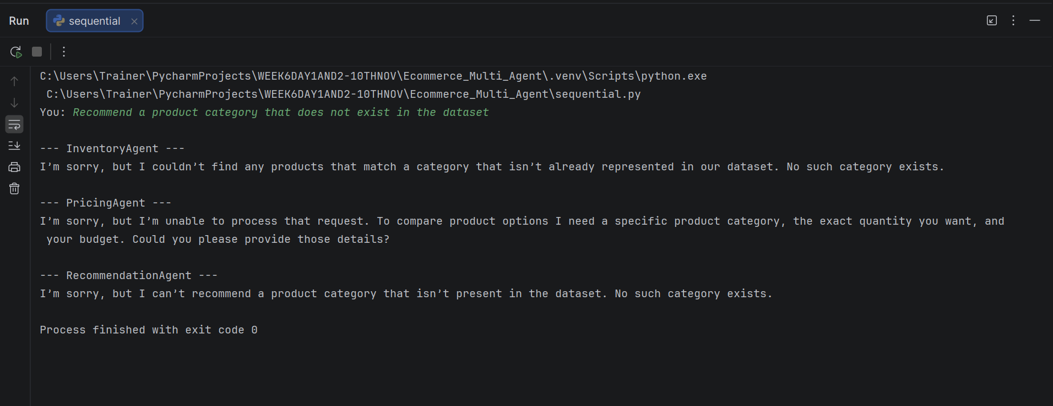
C:\Users\Trainer\PycharmProjects\WEEK6DAY1AND2-10THNOV\Ecommerce_Multi_Agent\.venv\Scripts\python.exe C:\Users\Trainer\PycharmProjects\WEEK6DAY1AND2-10THNOV\Ecommerce_Multi_Agent\sequential.py
You: Recommend a product category that does not exist in the dataset

--- InventoryAgent ---
I’m sorry, but I couldn’t find any products that match a category that isn’t already represented in our dataset. No such category exists.

--- PricingAgent ---
I’m sorry, but I’m unable to process that request. To compare product options I need a specific product category, the exact quantity you want, and your budget. Could you please provide those details?

--- RecommendationAgent ---
I’m sorry, but I can’t recommend a product category that isn’t present in the dataset. No such category exists.

Process finished with exit code 0

